Ideation Phase

Define the Problem Statements
Date: 31 January 2025
Team ID:LTVIP2026TMIDS91486
Project Name: HematoVision – Advanced Blood Cell Classification Using Transfer Learning
Maximum Marks: 2 Marks

Customer Problem Statement Template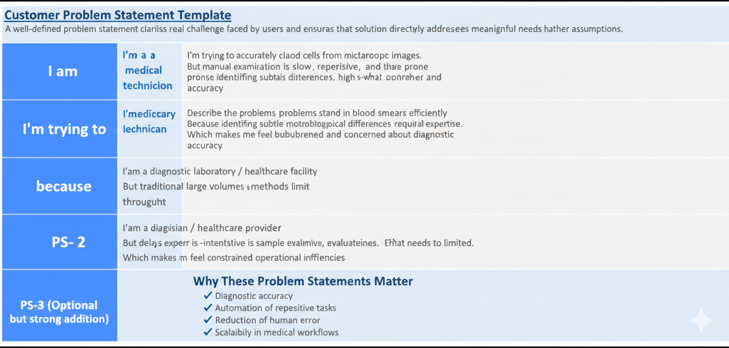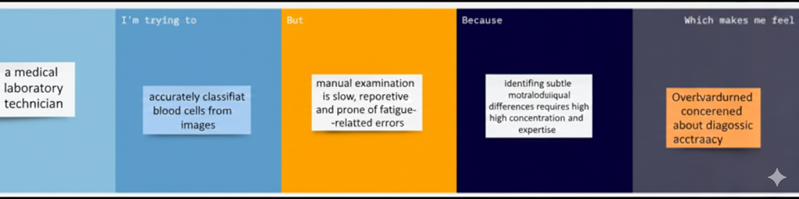
A well-defined problem statement clarifies the real challenge faced by users and ensures that the solution directly addresses meaningful needs rather than assumptions.

PS No. | User / Role | Goal / Trying to Do | Problem / But… | Reason / Because… | Feeling / Which makes me feel…
PS-1 | Medical laboratory technician | Accurately classify blood cells from microscopic images | Manual examination is slow, repetitive, and prone to fatigue-related errors | Identifying subtle morphological differences requires high concentration and expertise | Overburdened and concerned about diagnostic accuracy
PS-2 | Diagnostic laboratory / healthcare facility | Process large volumes of blood smear samples efficiently | Traditional analysis methods limit throughput | Expert review is time-intensive and resources are limited | Constrained by operational inefficiencies
PS-3 | Clinician / healthcare provider | Obtain reliable blood analysis results quickly | Delays can occur in sample evaluation | Cell classification relies heavily on manual workflows | Concerned about timely decision-making

